Statement of Work – GEN11 Verifier OS Deployment

This Statement of Work (SOW) is entered into this 18th November 2024 (the “SOW Effective Date”) by and between Exfo Solutions (“Client”) an affiliate of EXFO Inc and Capgemini UK Plc, a company incorporated in and existing under the laws of England & Wales (“Capgemini” or “Service Provider”).
NOW THEREFORE, in consideration of the mutual promises and covenants contained herein, and of other good and valid consideration, the receipt and sufficiency of which is hereby acknowledged, the Parties hereby agree as follows:
- Introduction

  - Services Agreement. This Statement of Work is entered into pursuant to and subject to that certain Framework Agreement (the “MSA”) dated 22nd January 2024 by and between the Parties, the terms of which, except as may be expressly modified or excluded herein, are incorporated herein by reference.
  - References. All references in this Statement of Work to Sections and attachments shall be to the Sections and attachments to this Statement of Work, unless otherwise specified.
  - Definitions. Terms used but not defined in this Statement of Work have the meanings given to them in the MSA.

- Term of Statement OF Work
This Statement of Work will commence on the SOW Effective Date set forth above and continue for as per program timelines defined in Section 8 or unless terminated as permitted under the MSA.
In case of termination without renewal and upon EXFO request, Service Provider shall provide exit assistance , as per MSA from 22nd January 2024
- Services

3.1 During the term of this Statement of Work, Service Provider will provide to the Client the Services specifically identified in this Statement of Work, all upon and subject to the terms and conditions specified in this Statement of Work and the MSA. Save as expressly set out in this Statement of Work, Service Provider shall not be obliged to provide any other services to the Client unless otherwise agreed via the Change control procedure.
Client has engaged Supplier to provide support for Porting and verification of verifier OS on GEN11 Servers for NV40-B program (“Phase 1 Project for Enabling UEFI support on Gen11 Servers”).
Supplier shall provide the following Services to Client under this SOW (collectively, the “Services”) as further described below:
- Focused on discovering, analysing, and providing fixes for booting the verifier OS using the UEFI boot option on Gen 11 architecture on best effort basis. Anything remaining will be taken up as part of Phase2.
On HPE DL-360 server [Gen11] platforms in fixed price model

3.2 Out Of Scope

The following list of items are not in the scope of the current proposal. These can be considered as separate proposal and project beyond the current proposed services:

- Functional and integration testing of the system
- Development of any application or services on the NV40-B platform/Product
- Development of new features for the solution
- Optimization for performance

.

- FEES
The fees for the Services are as follows: Total Fixed Fee: EUR 12600.
Supplier shall invoice Client upon Supplier’s completion of the milestones stated below. Under no circumstances will Client be obligated to pay Supplier more than the Total Fixed Fee except if otherwise agreed between Parties in a Change Order.
S.No | Description | Price (EUR)
1 | Kick off | 3000
2 | Phase 1 Completion | 9600

- Assumptions and Dependencies

  - Client will provide all necessary resources with remote access for this program. Basic resources include an HPEDL360 and minimal lab support. .
  - Initial Base SW package including (Current Linux kernel, File system, various utilities), and diagnostics/test software if available to be provided by Client by EXFO.
  - Capability to prepare development/test builds; access to the built environment will be provided by EXFO. Necessary development environment-related VM files or configurations will be provided if required.
  - Access to Test/ Lab environment and Tool licenses are available throughout the Project tenure

  - Any clarifications/support/information/review feedback from EXFO SME will be timely addressed with 2 working days.
  - Any changes to the requirement spec or addition of activities that are not specified in this SOW will be subject to change control
  - Issues related to chipset Hardware, Third party software, boot firmware, software, etc., shall be resolved by Client in a timely manner (with highest priority support) by chipset vendors (eg.,HP). Any delay may affect the Project schedule. While Supplier shall follow up, support would be needed from Client to push/expedite the case with vendors, if required.
  - All shipment costs, if required by the Client, and associated risk are the responsibility of Client.

- Client Responsibilities and Resources

  - Client shall be responsible for specification of deliverables monitoring of the work progress, and program management.

  - All specialized EXFO specific software and hardware tools reasonably needed for Service Provider to provide the Services shall be provided by Client.

- Responsibilities & Obligations:

- The Service Provider will be responsible for the coordination of the team, their availability and productivity.

- To receive Client training, and to execute trial project implementations, including feedback and collaboration with Client to improve such training, so as to be in a position to confidently commit to and fulfil the objectives below.
- To capture and understand the Client Customer’s business requirements (including systems and data landscape) in sufficient detail such that they can be addressed within the current scope of development.

- Identify technical and project implementation risks and then identify and take mitigation step to reduce impacts
- Contribute to the assessment of impact of potential functional, technical or project changes including affect on solution, deployment, timelines and resources associated
- Manages their own technical relationships with Customer personnel throughout the project duration acting as an on-site point of contact for current scope of work.
- Ensures the technical supply of individual deliveries conforms to what has been specified and maintains the delivery of said objects against agreed quality and scope. Escalates to the Services Team Project Manager as necessary if divergences are forecast or observed.
- Works with the Client Customer Success Manager, End Customer Project Leadership team and Services Team Project Manager to ensure assigned activities are appropriately prioritized towards tasks of highest value.
- Where needed, acts as an on-site communication point when technical issues arise and helps manage any dispute or conflict.

- Deliverables/Services:
Capgemini will provide the following Deliverables as set forth below, which will be reviewed at the end of each milestone.

Item | Phase duration and deliverable(s)
Kickoff | - Kickoff Presentation
Architecture and Feasibility Phase | - Duration: 4 weeks  - System Architecture and Feasibility Study w.r.t UEFI Boot  - Design Analysis Report document  - Patch files (if any on Bug fixes)

Acceptance Period: 10 business days
- Project Governance:
Personnel deployed on the project shall report status to Services Team Project Manager of their tasks and work progress as per agreed cadence. Personnel shall also participate in the daily stand-up meetings if any and other required meetings with Client, Customers or 3rd Parties as needed.
Services Team Project Manager shall provide project progress against plan, status reports, forecasts, action, risk and issue management, and other materials as requested, to Client Customer Success Management personnel in support of the governance of the work stated in this SOW.
The overall governance model between Service Provider and Client shall be as follows:

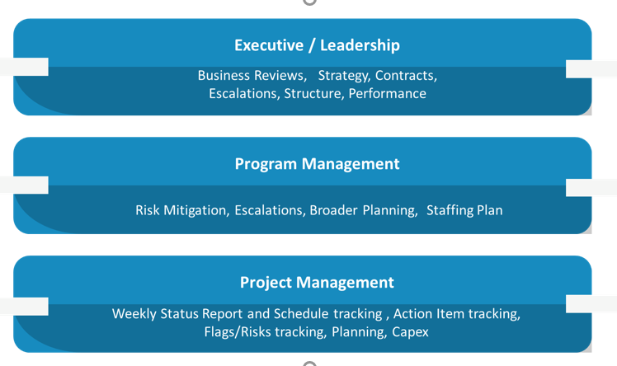
Service Provider shall work closely with Client team to understand the project requirements of each Client Customer.

Capgemini will conduct weekly progress meetings with Client to review the Action plan, review deliverables progress, schedule, open risks & mitigations and provide approval to deliverables.

- Reporting
1)

1) Service Provider should provide a weekly project status report (scorecard) to Client with its current status, progress, timeline, major issues encountered, resources, action planned for the following week and next steps/milestones. Proposed template in Annex 1 (EXFO Project Update Report Template V1.0)
2) In event of dealing with an urgent issue a regular report (twice a day) on progress through investigation and till resolution

- EXFO IT requirements:

• Service Provider to provide the Services Team laptops/systems with capabilities to run the RDP client and connect the Remote RDP session. o Example: Windows 10 Professional/Enterprise edition or macOS 12 have feature to establish the remote RDP session, whereas Windows 10 Home edition does not have this feature.
• The system must have open access to connect and use the remote desktop services as the internal portal works on https: port 443 (some organization put restrictions to run these services)
• Microsoft Authenticator application installed on the users Phone for the second factor authentication
• There are no specific hardware requirements but any system with 8 GB or more RAM is preferred
• Should have good Internet connection. Preferably with a speed of 10 Mbps or more.
• EXFO IT team to setup the required access for EXFO development & test servers on these systems (laptops) for the team to access remotely
• EXFO shall provide any additional equipment, hardware, software of licenses as required to execute the services mentioned in this SOW
• TeamViewer and Wireshark access may be needed to troubleshoot any problem on the Service Provider team member’s laptop/system.
• EXFO shall provide the required access for all the Service Provider team members.

- Invoicing Terms:
Fees shall be invoiced basis milestones defined.
Invoice shall be sent to EXFO Solutions Accounts Payable at the following email-ID: accounts.france@exfo.com
EXFO Solutions SAS
Z.A.C. Airlande
2 rue Jacqueline Auriol
Saint-Jacques-de-la-Lande CS 69 123
35091 RENNES CEDEX 9
FRANCE

PO Number must be written on the invoice.
In case of a delayed issue or absence of a Purchase Order, Service Provider can invoice based on actual efforts spent as agreed in the relevant signed SOW and shall be paid accordingly upon approval of the invoice except for ramp-up resources for which Service provider must receive a formal PO prior to the start of the services .

Invoicing shall align with active workstreams in the case of Service Provider delivering resources working across multiple projects workstreams.

IN WITNESS WHEREOF, the authorized representatives of the Parties have executed this Agreement as of the Effective Date.

Exfo Solutions.  (by its authorized representative) |  | Capgemini UK Plc  (by its authorized representative)
By: |  | By:
Name: |  | Name:
Title: |  | Title:
Date: |  | Date:

Annex 1 – Monthly Report

Weekly Report Template

